AI ASSISTED CODING
ASSIGNMENT-21
Veerla Sathvika
2303A52434
Batch:38
Lab 21 – Collaborative AI Coding: Pair Programming and Version Control Integration
Task 1 – AI-Assisted Pair Programming
• Use AI to generate an initial program (e.g., a simple To-Do List Manager).
• Ask AI to suggest enhancements (such as error handling, additional features, or refactoring).
• Compare the original and improved versions to understand the role of AI in collaboration.
Prompt:
Generate a simple To-Do List Manager program in Python with basic add, delete, and display features. Then suggest improvements like error handling and additional functionalities.
Code & Output:
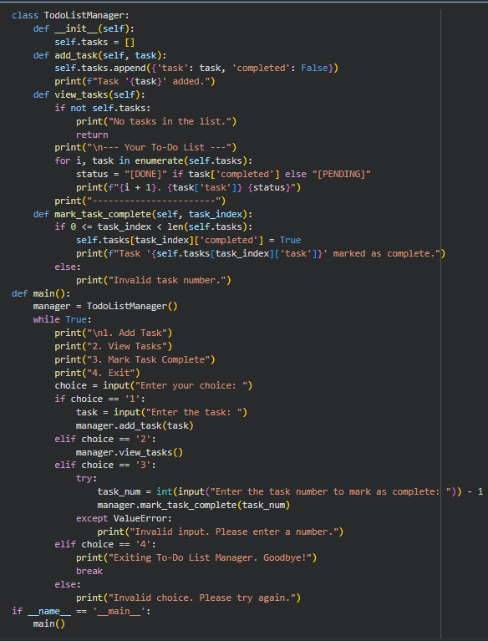
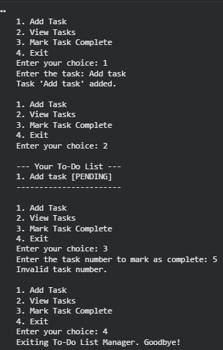
Explanation:
This task demonstrates how AI can act as a coding partner by generating an initial solution quickly. The student then interacts with AI to refine the code by adding features such as input validation, file storage, or a user-friendly interface. Comparing both versions helps understand how AI improves code quality and efficiency. It also highlights collaborative development between human thinking and AI suggestions. This process builds better problem-solving and coding practices.
Task 2 – Version Control Integration
Initialize a Git repository for your project.
Perform the following steps:
• Create and switch to a new branch.
• Add AI-assisted modifications.
• Commit with a meaningful message.
• Merge changes back into the main branch.
Reflect on how version control supports collaborative development with AI assistance.
Prompt:
Guide me through initializing a Git repository, creating a new branch, making changes, committing them, and merging back into the main branch.
Code & Output:
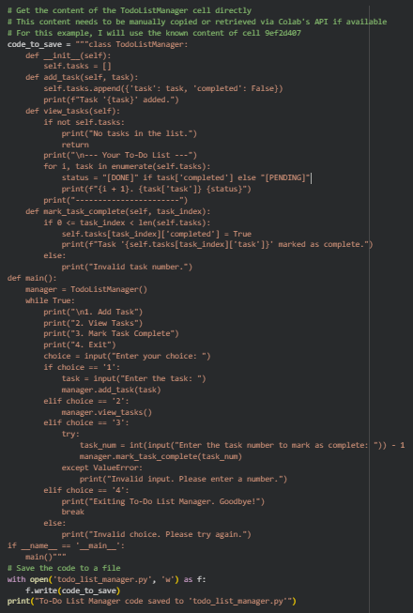
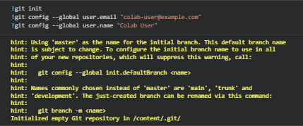
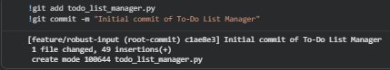
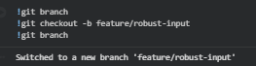
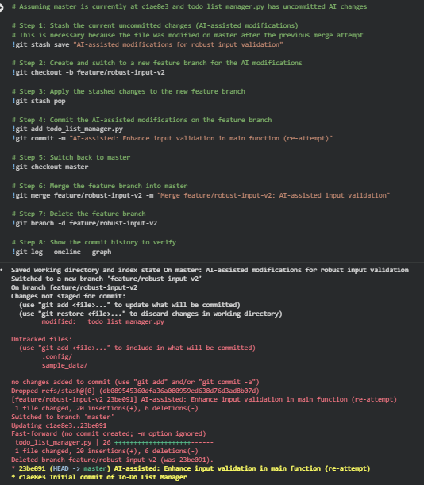
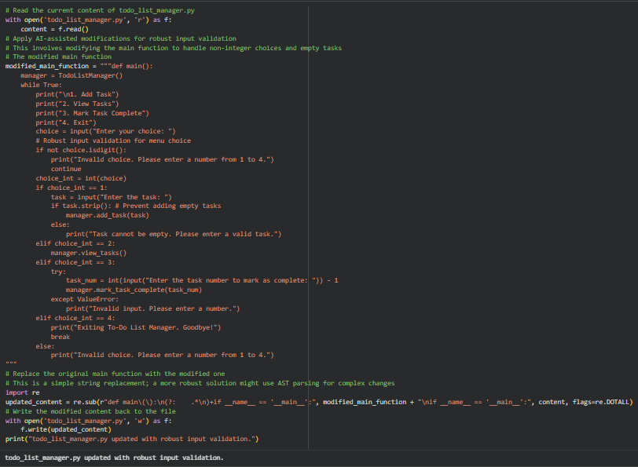
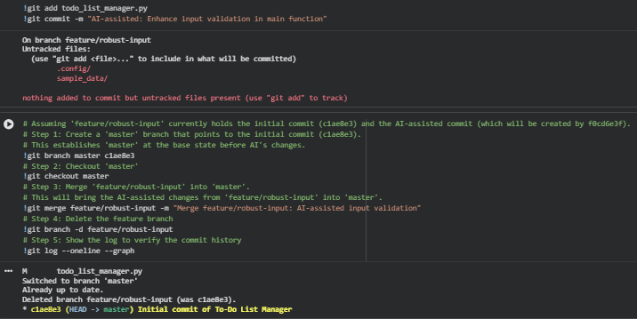
Explanation:
This task focuses on integrating version control into development using Git. It helps students understand how to manage code changes systematically by working in branches instead of directly modifying the main code. AI can assist by suggesting commands and best practices for commits. Merging changes ensures all updates are combined without conflicts. This reflects real-world collaborative workflows used in software development teams.
Task 3 – AI for Commit Message Generation
• Use AI to generate concise, meaningful commit messages based on the changes made.
• Compare AI-generated messages with human-written ones.
• Discuss how AI can improve documentation and traceability in Git history.
Prompt:
Generate clear and concise Git commit messages based on the code changes made, following best practices.
Code & Output:
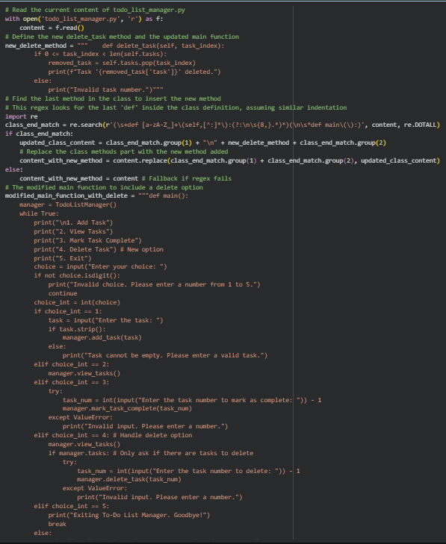
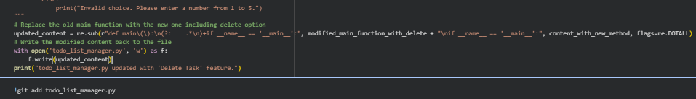
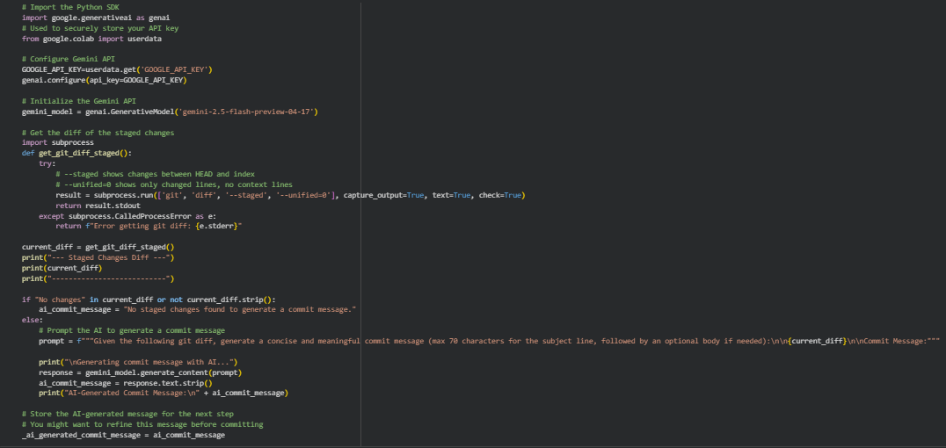
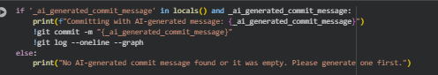
Explanation:
Here, AI is used to automate the process of writing meaningful commit messages. Good commit messages improve readability and make it easier to track project history. By comparing AI-generated messages with human-written ones, students learn what makes a message effective. AI can standardize formatting and ensure clarity. This enhances documentation and improves collaboration in team environments.
Task 4 – Pair Programming Simulation
• Student A writes the initial version of a program.
• Student B, with AI assistance, suggests improvements or adds features.
• Both students collaborate using Git branching and merging to integrate their work.
Prompt:
Simulate pair programming where one developer writes initial code and another improves it with AI suggestions, using Git for collaboration.
Code & Output:
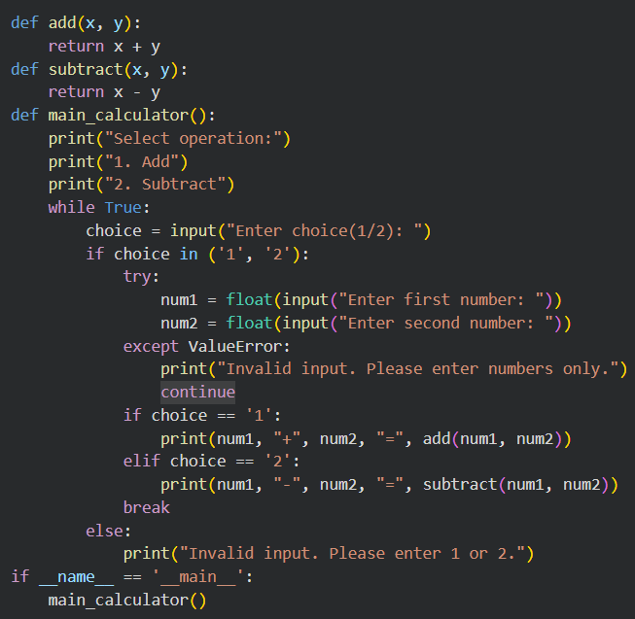
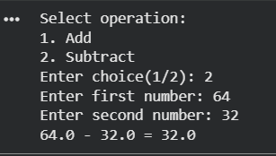
Explanation:
This task mimics real-world pair programming where two developers collaborate on the same project. One focuses on writing the base code, while the other enhances it using AI tools. Git branching allows both contributors to work independently and then merge their work smoothly. This improves teamwork, code quality, and problem-solving skills. It also shows how AI can act as an assistant in collaborative coding environments.

